# **Objective:** To evaluate the performance of a machine learning model in predicting prices for various crops using an extended dataset.

--------------------------------------------------------------------------------------------------------------

## Dataset:

The dataset includes:

* Crop
* Date
* Real-Time Price (Actual Price)
* Prediction (Predicted Price)
* Deviation (Difference between Real-Time and Prediction)
* %Accuracy (Accuracy of the Prediction)

## Data Overview:

The dataset covers dates for each crop with corresponding real-time and predicted prices. Data spans from 04/03/2024 to 13/03/2024 for corn, cotton, tomato, onion, and paddy, with potato data extending to 27/04/2024.

## Analysis Approach:

1. **Accuracy Calculation**:
   * 
   * Deviation and accuracy are computed for each crop and date.
2. **Descriptive Statistics**:
   * Average real-time price, predicted price, deviation, and accuracy percentage are calculated for each crop.

**Key Findings and Output:**

1. **Corn**:
   * Average Real-Time Price: 2278.33
   * Average Predicted Price: 2196.35
   * Average Deviation: 81.98
   * Average Accuracy: 96.40%

1. **Cotton**:
   * Average Real-Time Price: 7110.06
   * Average Predicted Price: 7185.30
   * Average Deviation: 75.24
   * Average Accuracy: 98.94%

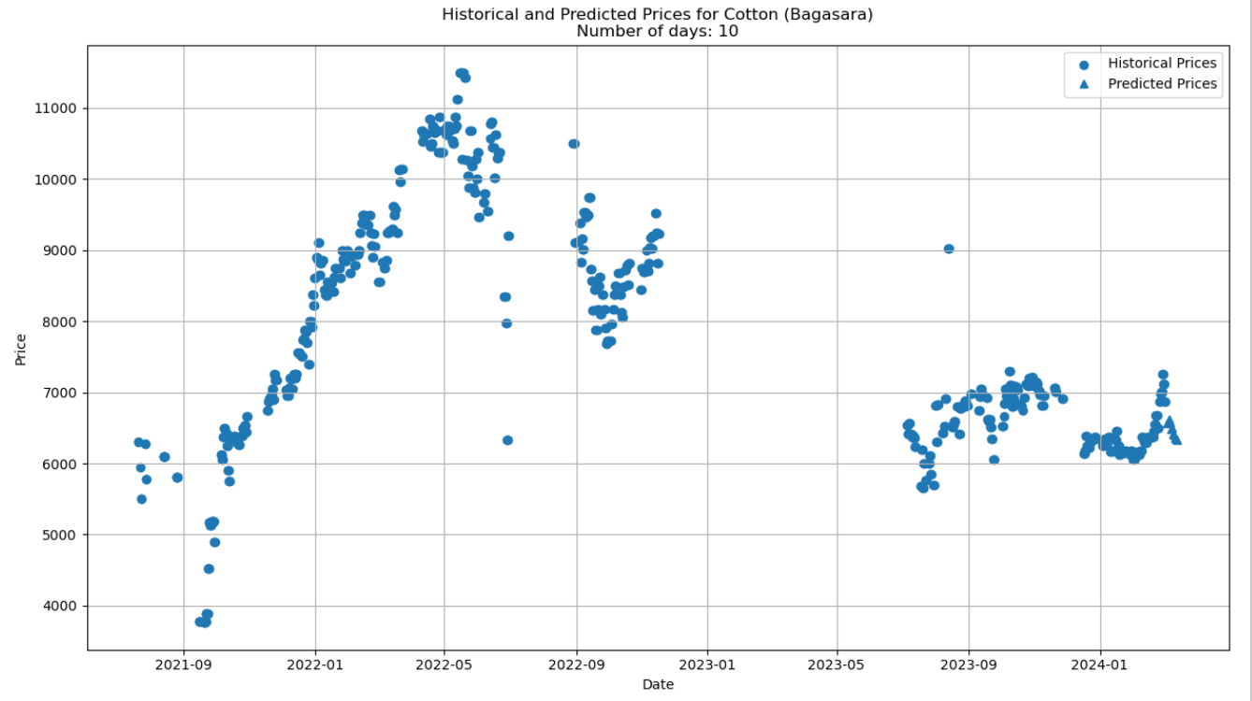

1. **Tomato**:
   * Average Real-Time Price: 1055.00
   * Average Predicted Price: 2762.70
   * Average Deviation: 1707.70
   * Average Accuracy: -61.87% (Poor model performance)

1. **Onion**:
   * Average Real-Time Price: 1255.56
   * Average Predicted Price: 1665.85
   * Average Deviation: 410.29
   * Average Accuracy: 67.32%

1. **Paddy**:
   * Average Real-Time Price: 1200.00
   * Average Predicted Price: 1238.12
   * Average Deviation: 38.12
   * Average Accuracy: 96.82%

1. **Potato**:
   * Average Real-Time Price: 2333.33
   * Average Predicted Price: 1499.38
   * Average Deviation: 833.95
   * Average Accuracy: 64.26%

**Conclusion:**

The model shows high accuracy for predicting cotton (98.94%), corn (96.40%), and paddy (96.82%) prices but performs poorly for tomatoes. For onions and potatoes, accuracy is moderate. This analysis highlights the model's strengths and areas for improvement.

**Visual Analysis:**

The visual representation of the data (image provided) shows detailed predictions and deviations for each crop. The table in the image provides a clear overview of the model's performance across different dates and crops. This can help identify trends and patterns in prediction accuracy and highlight specific areas where the model needs adjustment